ČETRTEK, 19. 3. 2020
FUN TIME  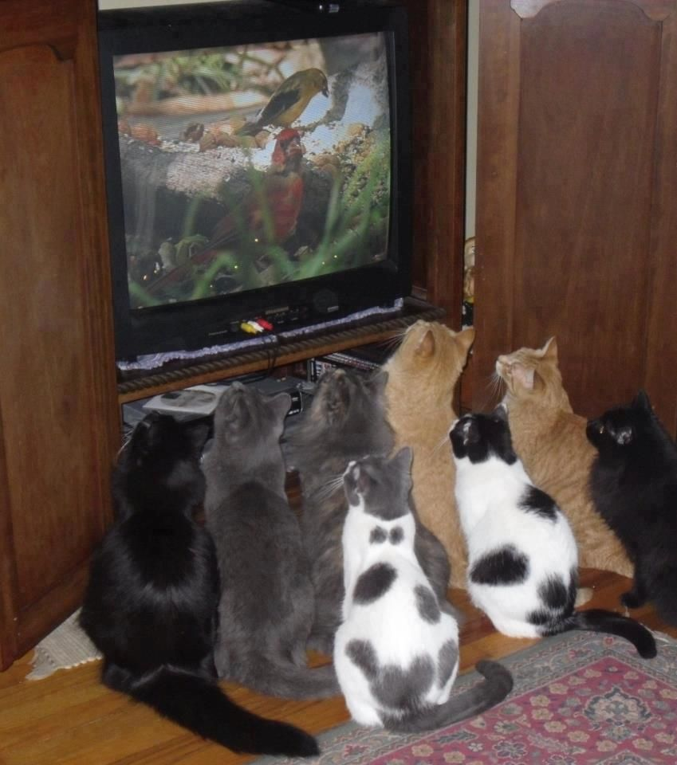 | Telovadi, zapleši in zapoj po angleško (povabi še bratca/sestrico in morda tudi mamico in očka):  - https://www.youtube.com/watch?v=mrkIhHnKQTs  - https://www.youtube.com/watch?v=b1qNxeMImoE  - https://www.youtube.com/watch?v=TSdeIhmv6v0
HOW MANY STARS?
Oglej si sliko, prepiši povedi v zvezek in dopolni oz. odgovori na vprašanja. Glej primer 1, ki je že rešen.

- How many yellow stars? There are SIX yellow stars.
- How many blue stars?
- How many pink stars?
- How many red stars?
- How many orange stars?
- How many brown stars?
- How many purple stars?

