Zdravo, učenjak/učenjakinja!
Veseli me, da se lotiš tudi teh nalog. Danes sem ti pripravila vaje bralnega razumevanja in tudi nekaj vaj slovnice za ponovitev.
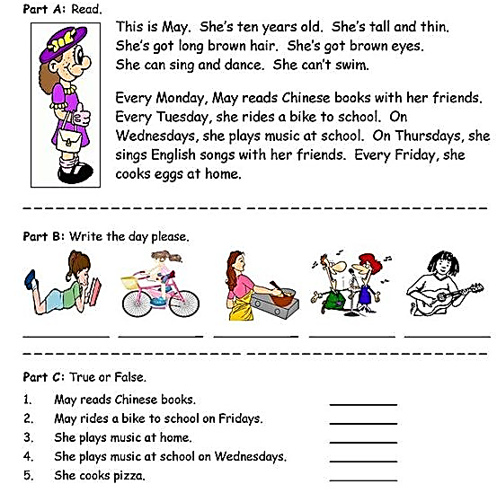

Zapiši nikalne in vprašalne oblike glagola imeti in biti.
+ Grandma has got two black cats.
-__________________________________________________________
? __________________________________________________________

We have got a new and fast car.
-__________________________________________________________
? __________________________________________________________

Sally has got green eyes.
-__________________________________________________________
? __________________________________________________________

She is tall and thin.
-__________________________________________________________
? __________________________________________________________

They are sad, because it is bad weather.
-__________________________________________________________
? __________________________________________________________
I am in the garage.
-__________________________________________________________

? _________________________________________________________

