LITTLE MOUSE
AKTIVNA DEKLAMACIJA

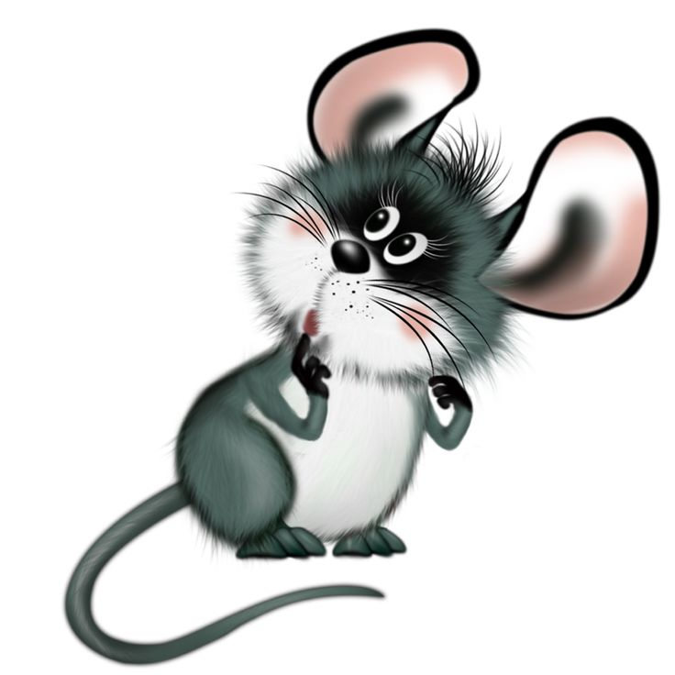
LITTLE MOUSE, LITTLE MOUSE,
TURN AROUND (OBRNI SE).

LITTLE MOUSE, LITTLE MOUSE,
TOUCH THE GROUND (DOTAKNI SE TAL).

LITTLE MOUSE, LITTLE MOUSE,
CLOSE THE DOOR (ZAPRI VRATA).

LITTLE MOUSE, LITTLE MOUSE,
COUNT TO FOUR (ŠTEJ DO ŠTIRI).

LITTLE MOUSE, LITTLE MOUSE,
TURN OFF THE LIGHT (UGASNI LUČ).

LITTLE MOUSE, LITTLE MOUSE,
SAY GOOD NIGHT (ZAŽELI LAHKO NOČ).

