The animal worksheet
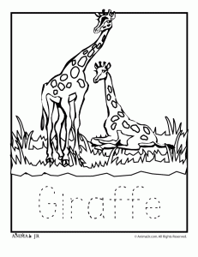
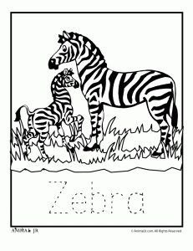
ZEBRA, COW, MOUSE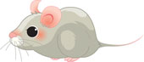, MONKEY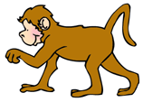, KANGAROO,
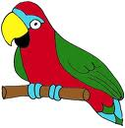
PARROT, HORSE, CAMEL, CAT, DOG, DOLPHIN, GIRAFFE,

Read about the animals and guess their names.
This animal is small. It often lives in people’s houses. Some people are scared of it. And this animal is scared of cats! What is it?
This animal is very big, has long legs, long neck and lives in Africa. What is it?
This animal is quite big. It is brown, but can also be black, white or grey. It helps people in the village to work in the fields. You can ride on its back if you can! What is it?
This animal is quite big and lives on the farm. People like these animals because they give them a lot of milk. What is it?
This animal lives in people’s houses or on the farm. It barks and people like it. Cats are sometimes scared of it but not always. What is it?
This animal is very funny and nice. You can see it in the ZOO but it lives in Africa. It likes bananas very much What is it?
This animal is like a horse but lives in Africa. It has black and white stripes on its body. What is it?
This animal is very big and lives in water but it is not a fish! It is very nice and friendly and sometimes can save people’s lives! What is it?
This animal is very nice and people have it at home as a pet in the cage! It has got very nice and colored feathers. What is it?
This animal is small and very nice. It lives in people’s houses. People like it because this animal catches mice! What is it?
This animal is big. Sometimes they can walk in very hot weather and not drink anything for a very long time! What is it?
This animal lives in Australia. It is big and very nice and can jump very fast. It sometimes keeps its baby in the pocket on the body. What is it?
