HEAD, SHOULDERS, KNEES AND TOES

HEAD, SHOULDERS, KNEES AND TOES,
KNEES AND TOES.
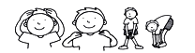
HEAD, SHOULDERS, KNEES AND TOES,
KNEES AND TOES.
AND EYES AND EARS AND MOUTH AND NOSE.

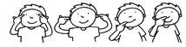
HEAD, SHOULDERS, KNEES AND TOES,
KNEES AND TOES.
http://supersimplelearning.com

