PONAVLJANJE IN UTRJEVANJE
(DOP. POUK, 10. 4.)
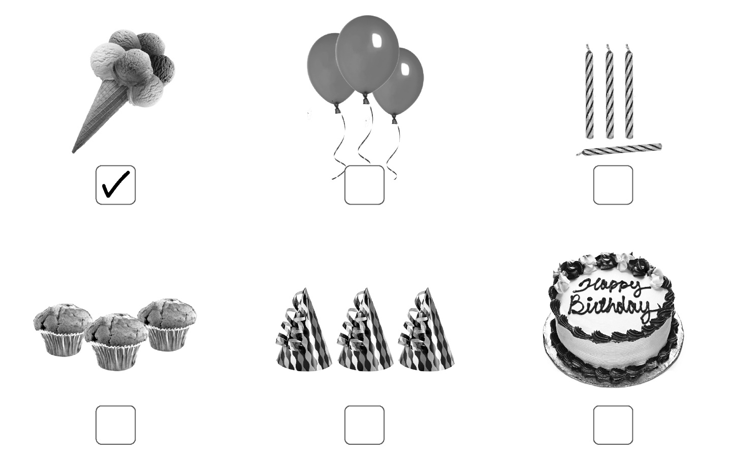
- What is on the picture? Write. Kaj je na sliki? Zapiši.

- What can we do on a birthday party? Write. Kaj lahko počnemo na roj. zabavi? Zapiši.
We can eat a birthday cake.
_________________________________________________________________________________________________________________________________________________________________________________________________________________________________________________________________________________________________________________________________________________________________________________________________________________________________________

- Complete the sentences.
Dopolni povedi.

terrarium
A rat lives in a .

A cat lives in a .
A dog lives in a .
A rabbit lives in a .
A bird lives in a .
A goldfish lives in a .

- Answer. Odgovori.
Have you got a cat? _______________________________________
Have you got a mouse?____________________________________
Do you like marbles?______________________________________
Do you like toy cars?______________________________________
Does your father like teddy bears? __________________________________

