PONAVLJANJE IN UTRJEVANJE
(DOP. POUK, 10. 4.)
- Read Anja's text about her timetable. Complete the timetable.
Preberi Anjino besedilo o njenem urniku. Dopolni urnik.

Monday Tuesday Wednesday Thursday Friday
English
8:15-9:00 Science Slovene
9:15-10:00 Science Art PE Science English
10:15-11:00 Maths Maths Slovene
11:05-11:50 Slovene Maths Slovene PE
11:55-12:40 Social Studies PE Social Studies
13:00-13:45 HE Music

My favourite school subject is English. We have English three times a week, on Mondays, Wednesdays and on Fridays. I like English because I think it's useful to learn another language. I also enjoy Social Studies because the lessons are fun. We have Social Studies three times a week on Mondays, Thursdays and Fridays. I also like Maths, I'm good at numbers. We have Maths four times a week, on Mondays, Tuesdays, Wednesdays and Thursdays. I also enjoy Slovene because I like reading. We have Slovene five times a week, once on Mondays, Wednesdays and Fridays, and twice on Thursdays. I quite like Art as well. We have two lessons of Art on Tuesdays. I don't like Music very much, because I'm not good at singing. We have Music twice a week: on Tuesdays and on Thursdays. We have PE three times a week, on Tuesdays, Wednesdays and twice on Fridays.

- Look at the picture. Name the places.
Oglej si sliko. Poimenuj prostore.

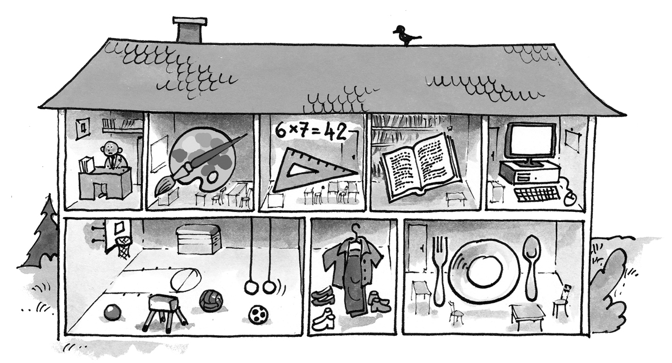

In the locker room.

Gym

- Poimenuj živali.
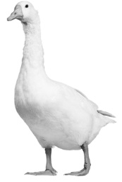

- A B C
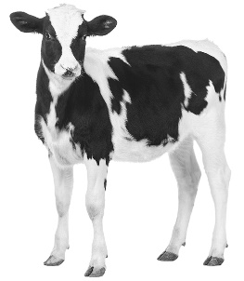
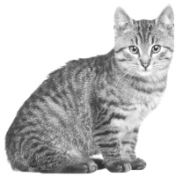

- Read the text and write the names of the places into the map.
Preberi besedilo in na zemljevid vpiši imena stavb.

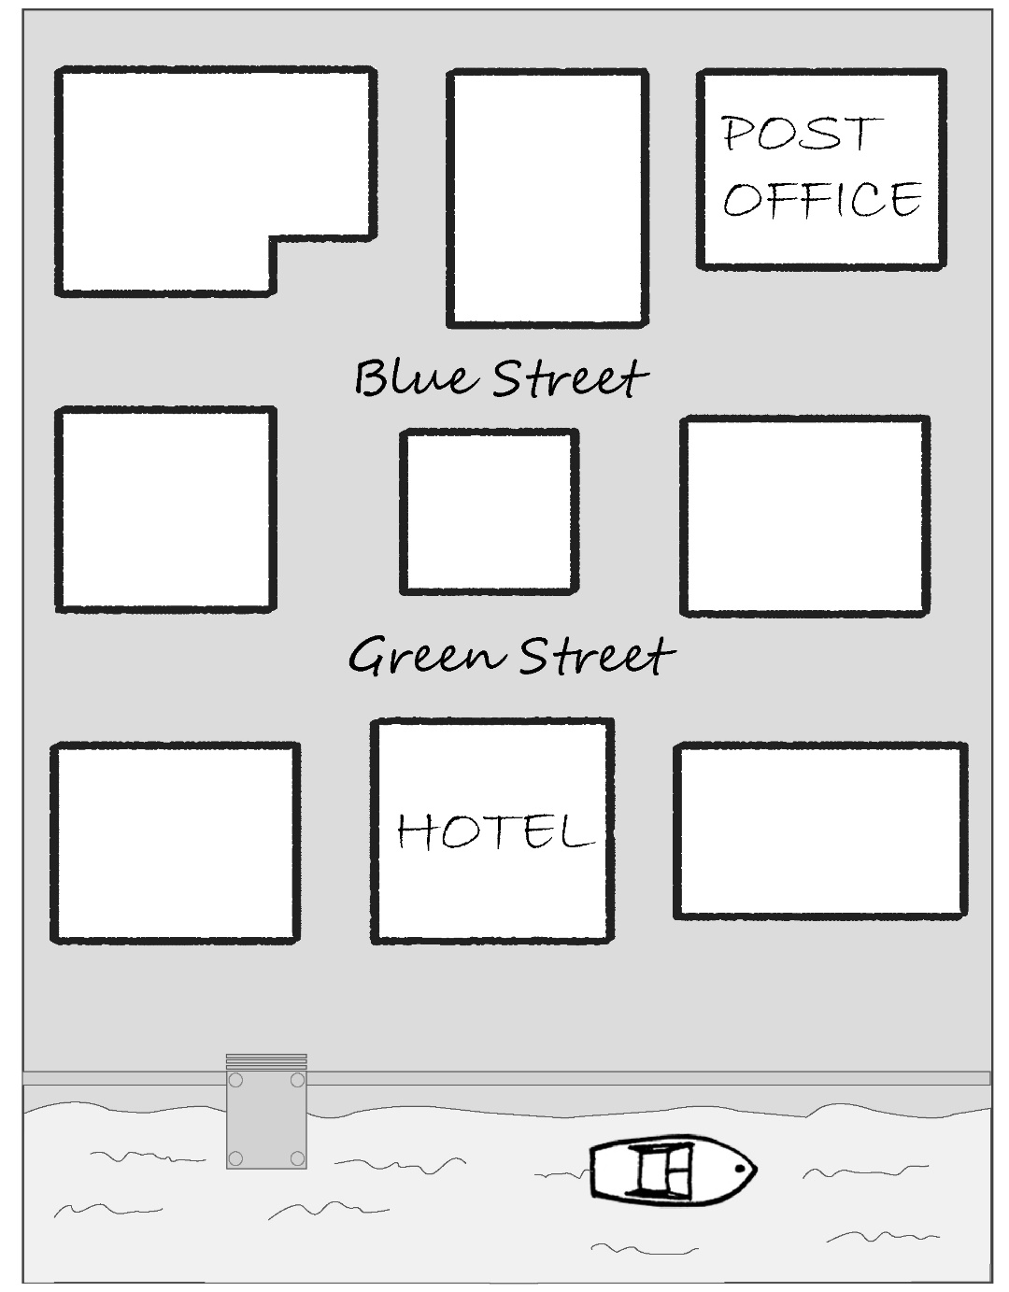

There is a hotel on the Green Street next to the river. Next to the hotel, on the right, there is a restaurant. There's also a cinema on Green Street. There's also a church opposite to the hotel. Next to the church, on the left side there is a toy shop. Between the restaurant and the post office there is a school. In Blue Street there is a pet shop between the hospital and the post office.

