Let's repeat – PONOVIMO
V PRIMERU, DA SI NALOG NE MOREŠ NATISNITI, JIH REŠUJ V ZVEZEK.
- Odgovori na vprašanja zase.
Npr. Do you like marbles? Yes, I do.
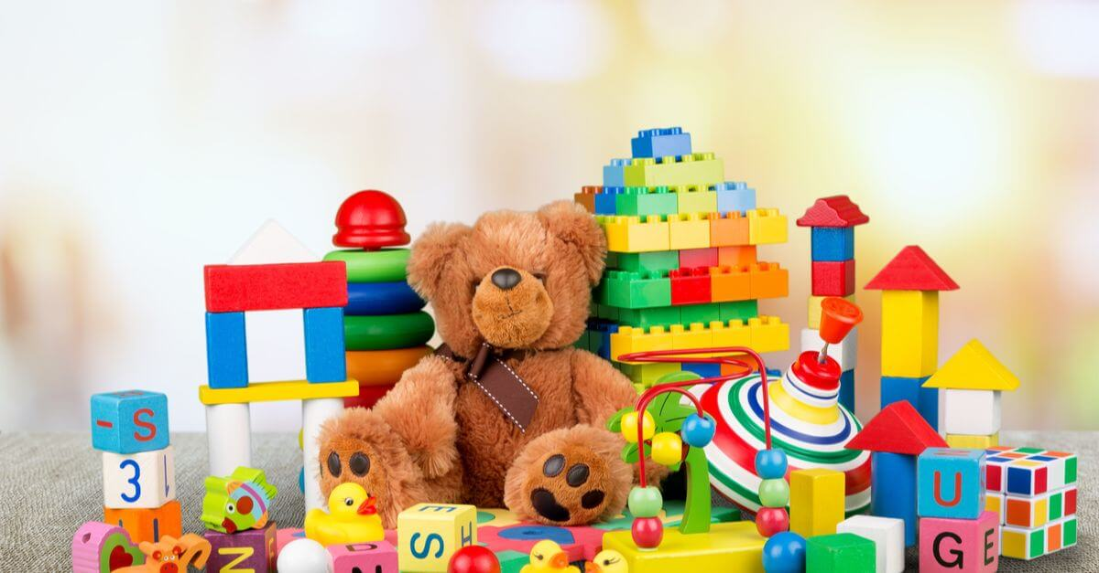
- Do you like kites?
- Do you like puzzles?
- Do you like prams?
- Do you like skipping ropes?
- Do you like board games?
- Do you like watercolours?
- Do you like lollipops?
- Do you like crowns?
- Do you like biscuits?
- Do you like paper cups and straws?

- Preberi spodnje besedilo. Vstavi manjkajoče besede. Dve besedi sta odveč.

cake, Monday, toy, like, don't like, house, marbles, May
Hello,
My name is Mia. I like toys! My favourite _______ is my blue doll. I _________ skipping ropes and balls, but I ____________ cars and trains. Cars and trains are for boys!
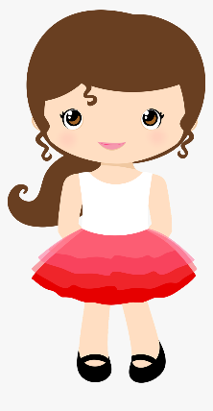
My brother's favourite toys are ____________. Marbles are small and fast. My birthday is in _________. I invite my friends to a birthday party! We eat a birthday _______, biscuits and pizza!
What about you? Write to me.
Mia
Bi poskusil/-a odpisati Miji na pismo in povedati, katere so tvoje najljubše igrače, katerih ne maraš in kdaj imaš ti rojstni dan?
____________________________________________________________________________________________________________________________________________________________________________________________________________________________________________________________________________________________________________________________________________________________________________
- Poglej in napiši.
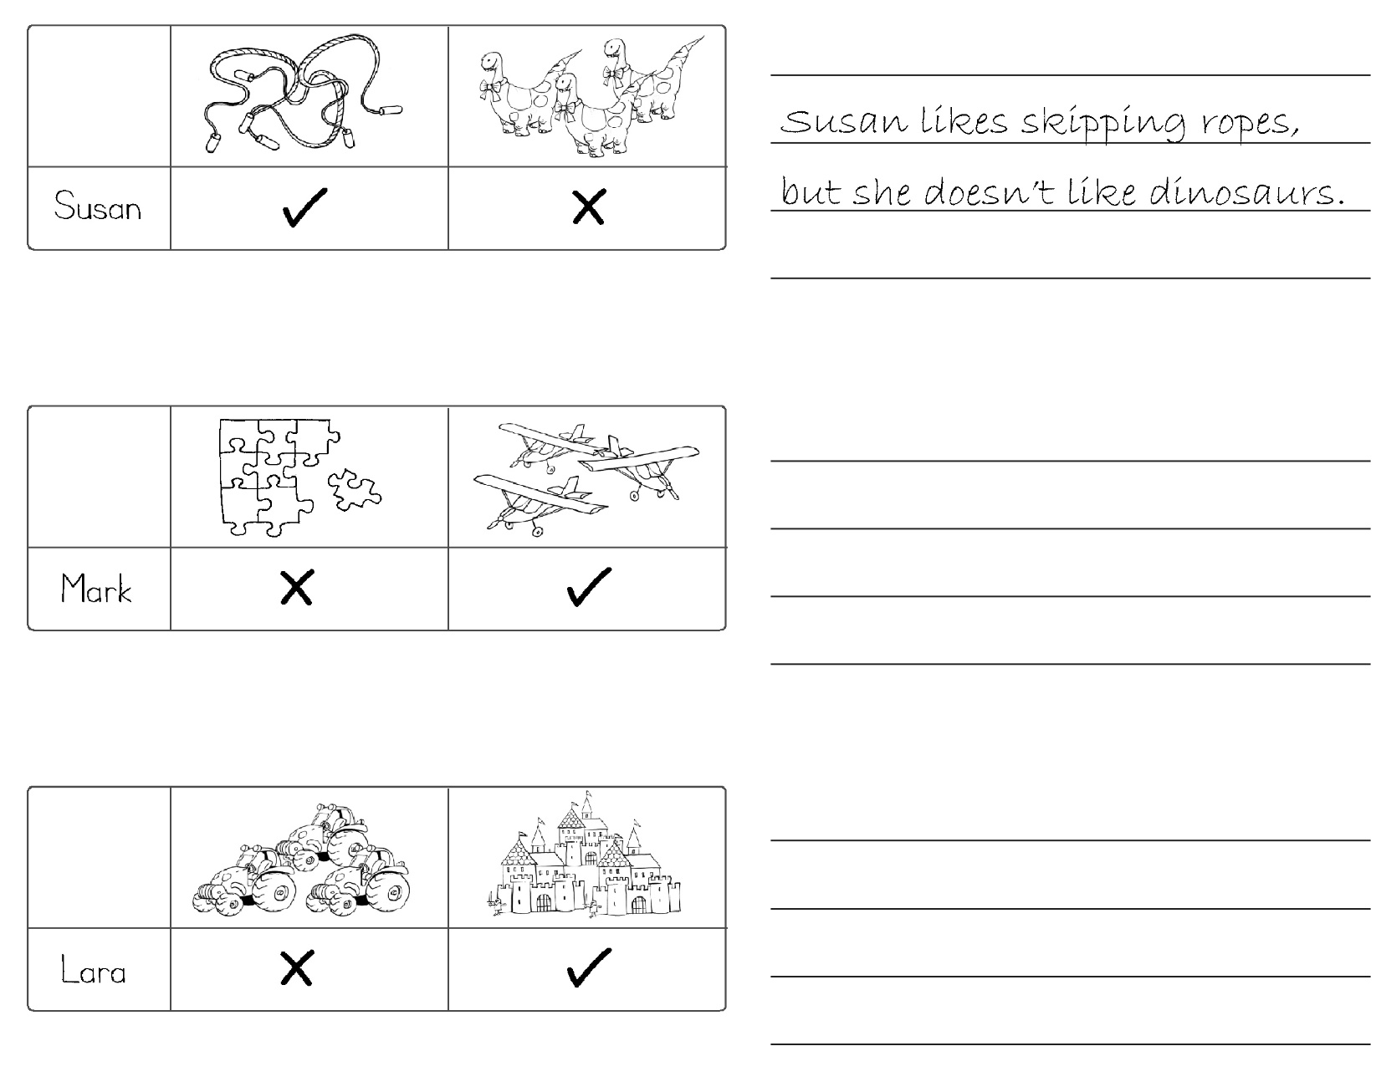

MY DICTIONARY_UNIT 4
IZDELAJ SI SLOVARČEK NOVIH BESED.
MOJ SLOVARČEK (ENOTA 4)
ENGLISH | SLOVENE

