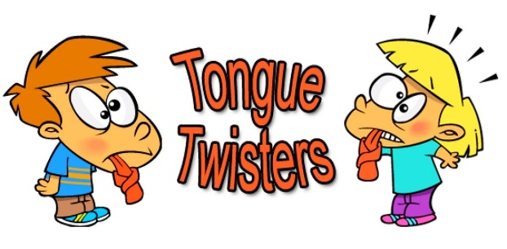
TONGUE TWISTERS

- RED BULB BLUE BULB RED BULB BLUE BULB RED BULB BLUE BULB.
- I WISH TO WISH THE WISH YOU WISH TO WISH, BUT IF YOU WISH THE WISH THE WITCH WISHES, I WON’T WISH THE WISH YOU WISH TO WISH.
- TOY BOAT. TOY BOAT. TOY BOAT.
- SHE SELLS SEASHELLS ON THE SEASHORE.

