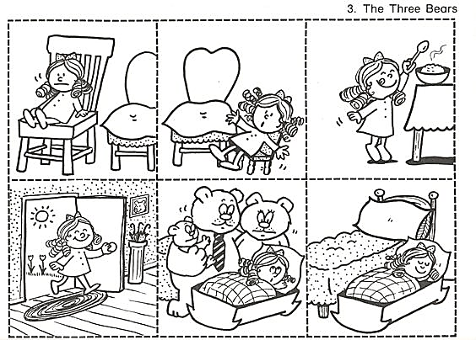
GOLDILOCKS AND THE THREE BEARS

