BODY PARTS SONG
(MELODIJA MOJSTER JAKA)
WRITTEN BY TEACHER PETRA

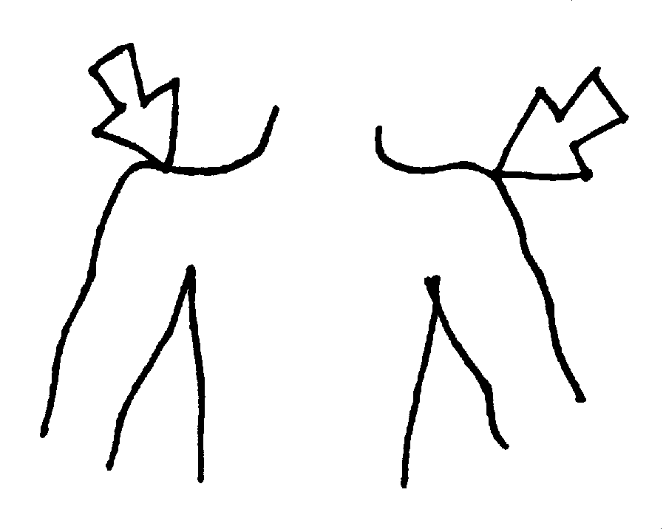
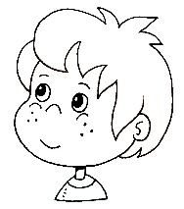
HEAD AND SHOULDERS

HEAD AND SHOULDERS

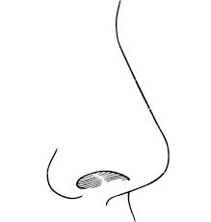
NOSE AND EARS
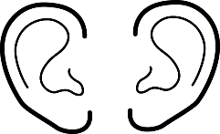

NOSE AND EARS

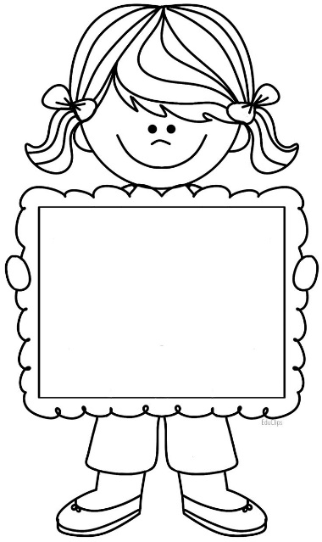
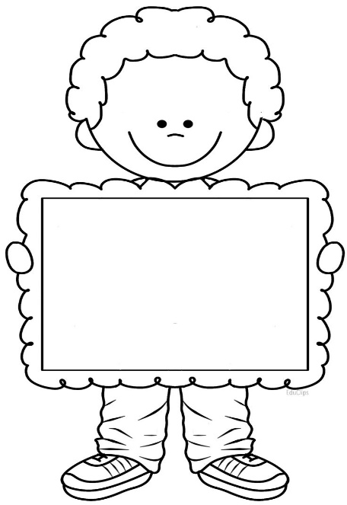
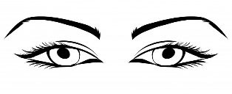
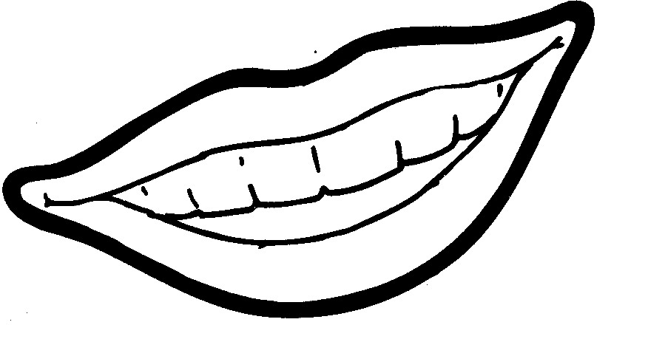
MOUTH AND EYES

MOUTH AND EYES
THIS IS ME.
TO SEM JAZ.
THIS IS ME.
TO SEM JAZ.

THIS IS ME
THIS IS ME

